COINS COLLECTION OF Dr. PRADEEP DAS
INDIA | 5 Rupees | Bal Gangadhar Tilak – 150th Birth Anniversary | 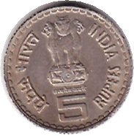 | 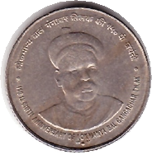
INDIA | 25 Paise | Rural Women’s Advancement - 1980 | 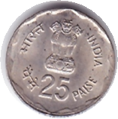 | 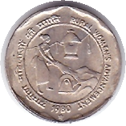
INDIA | 5 Rupees | K. Kamaraj (1900 – 1975) | 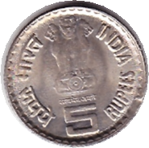 | 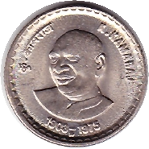
INDIA | 5 Rupees | 75 years of Dandi march – 1930:2005 | 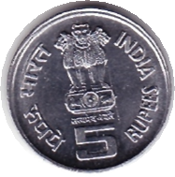 | 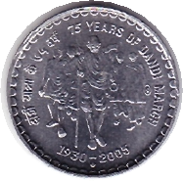
USA |  | Bicentennial of US independence :  1776 - 1976 | 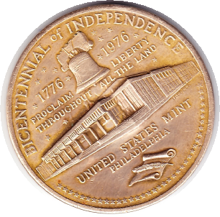 | 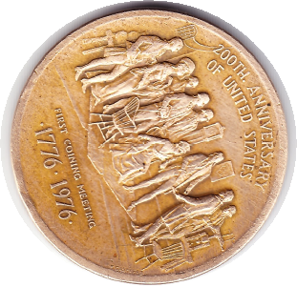
INDIA | 10 Rupees | Unity in diversity | 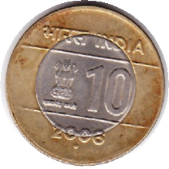 | 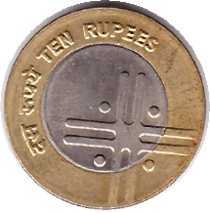
INDIA | 50 Paise | Fisheries Industry - 1986 | 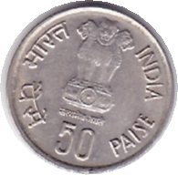 | 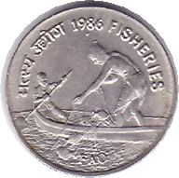
INDIA | 2 Rupees | 2006 – Unity in diversity | 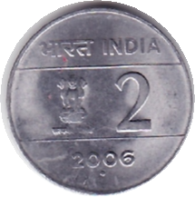 | 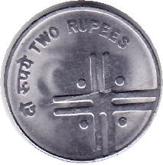
INDIA | 10 Rupees | 2009 - Connectivity | 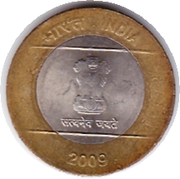 | 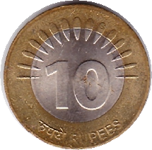
INDIA | 5 Rupees | 50th Anniversary of United Nations - 1995 | 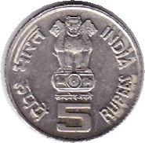 | 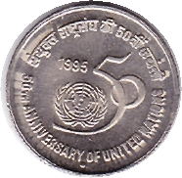
INDIA | 5 Rupees | 1884 – 2009 : 125th Bierh Anniversary of Dr. Rajendra Prasad | 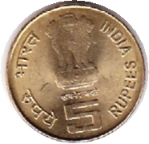 | 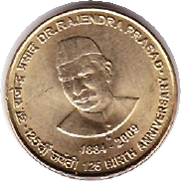
INDIA | 5 Rupees | 1945 – 1995 :  Food and Agriculture Organization | 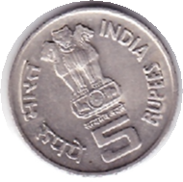 | 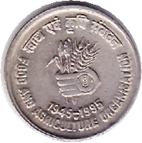
INDIA | 5 Rupees | 1956 – 2006 : 50 years of ONGC | 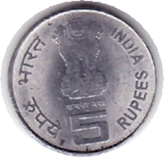 | 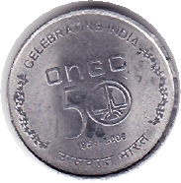
INDIA | 5 Rupees | 1919 - 1994 : ILO – World of Work | 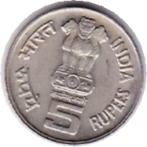 | 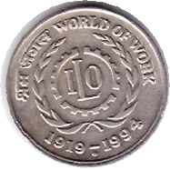
INDIA | 5 Rupees | 2004 – Birth Centenary of Lal Bahadur Shastri | 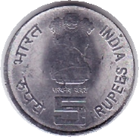 | 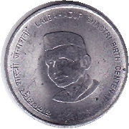
INDIA | 2 Rupees | 1809 – 2009 : Louis Braille | 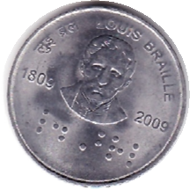 | 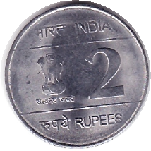
INDIA | 2 Rupees | 1998 : Deshbandhu Chittaranjan Das 1870 - 1925 | 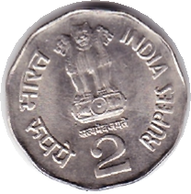 | 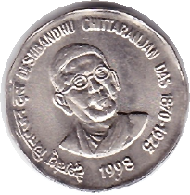
INDIA | 5 Rupees | Jagath Guru Narayana Gurudev | 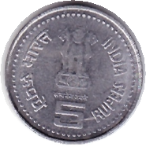 | 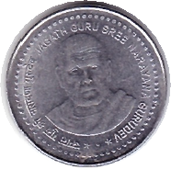
INDIA | 1 Rupee | 1994 : International Year of the Family | 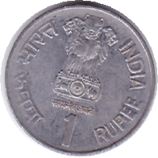 | 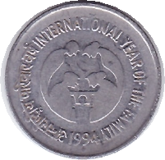
INDIA | 5 Rupees | 1825 – 1917 : Dadabhai Naoroji | 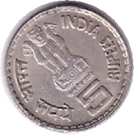 | 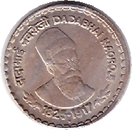
INDIA | 2 Rupees | 2011 – New Rupee Currency Symbol | 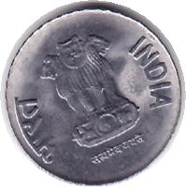 | 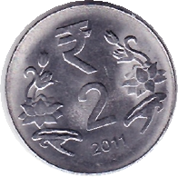
INDIA | 5 Rupees | 2009 | 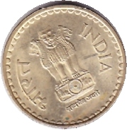 | 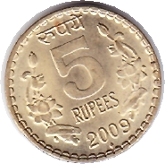
INDIA | 5 Rupees | 1996 – Mother’s Health is Child’s Health | 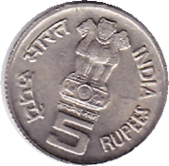 | 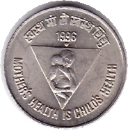
INDIA | 2 Rupees | 1995 – Agriexpo95 | 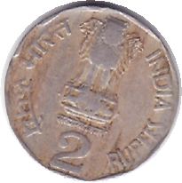 | 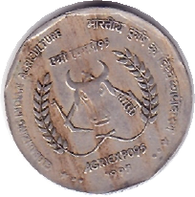
INDIA | 5 Rupees | 2001 – Bhagwan Mahavir – 2600th Janma Kalyanak | 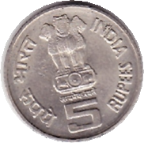 | 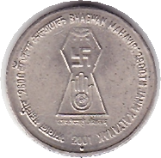
INDIA | 25 Paise | 1982 – IX Asian Games DELHI | 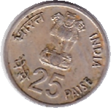 | 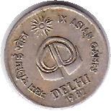
U.K. | 1 Penny | Elizabeth II | 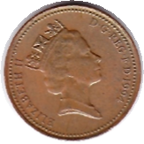 | 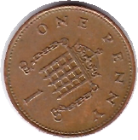
INDIA | 1 Rupee | 1901 – Empress Victoria | 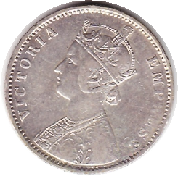 | 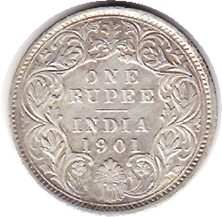
INDIA | 50 Paise | 1935 – 1985 : Reserve bank of India – Golden Jubilee | 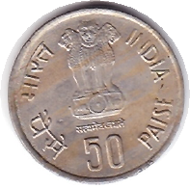 | 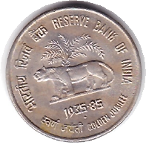
INDIA | 5 Rupees | 1989 – Jawahar Lal Nehru – Birth Centenary | 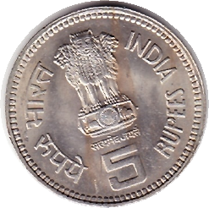 | 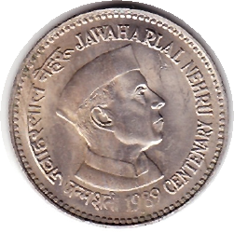
INDIA | 1 Rupee | 1985 – International Youth Year | 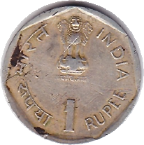 | 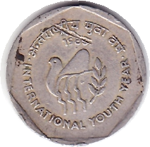
INDIA | 3 Paise | 1965 | 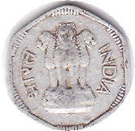 | 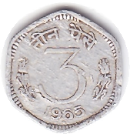
INDIA | 1 Rupee | 1904 – King & Emperor Edward VII | 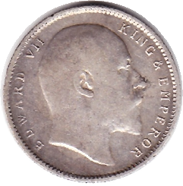 | 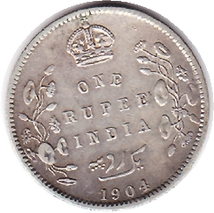
INDIA | 2 Rupees | 1998 – Sri Aurobindo – All Life is Yoga | 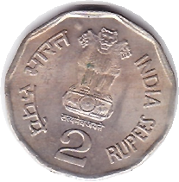 | 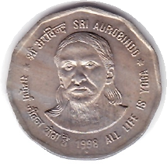
INDIA | 1 Rupee | 1991 – Tourism Year | 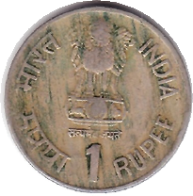 | 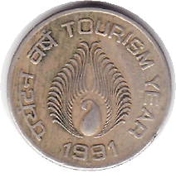
INDIA | 1 Rupee | 1997 – Cellular Jail – Port Blair | 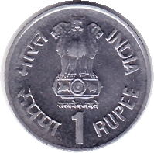 | 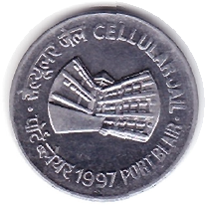
INDIA | 1 Paisa | 1973 | 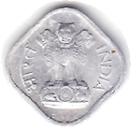 | 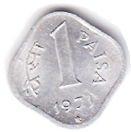
INDIA | 1 Rupee | 1942 – 1992 : Quit India Movement – Golden Jubilee | 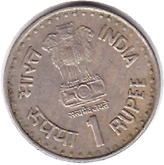 | 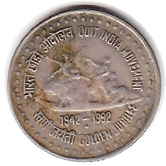
INDIA | 10 Paise | 1990 | 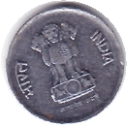 | 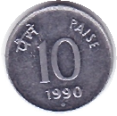
INDIA | 20 Paise | 1988 | 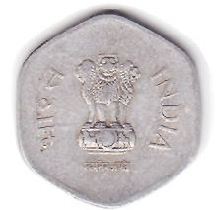 | 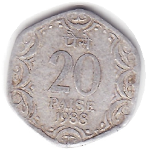
USA | 1 Dollar | 1979 – Liberty – In God We Trust | 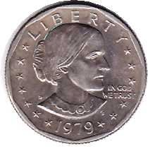 | 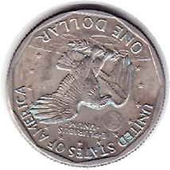
INDIA | 1 Rupee | 1999 : Sant Dnyaneshwar 1274 - 1296 | 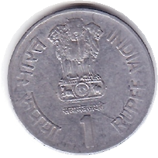 | 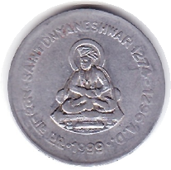
CANADA | 1 Cent | 1969 – Elizabeth II | 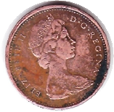 | 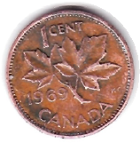
USA | 1 Cent | 1996 | 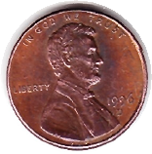 | 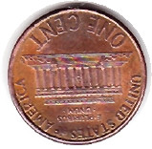
INDIA | 1 Rupee | 1915 – George V – King & Emperor | 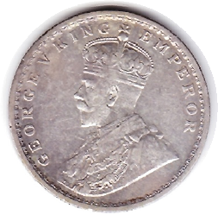 | 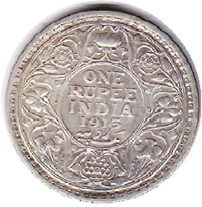
INDIA | 1 Rupee | 1995 – World Tamil Conference – Sailt Thiruvalluyar | 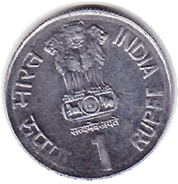 |  | 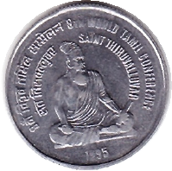
CANADA | 1 Cent | 1957 – Elizabeth II | 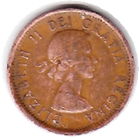 | 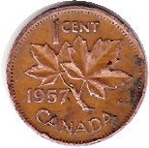
U.K. | 1 New Penny | 1976 - Elizabeth II | 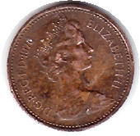 | 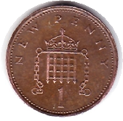
Hong Kong | 50 Cents | 1994 | 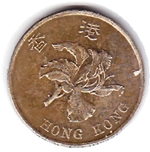 | 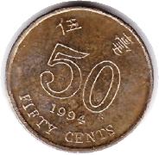
INDIA | 1 Rupee | 1992 – World Food Day – Food & Nutrition | 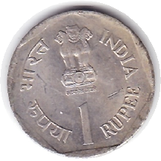 | 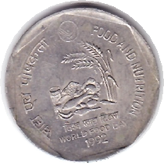
INDIA | 1 Rupee | SAARC Year – 1990 – Care for the Girl Child | 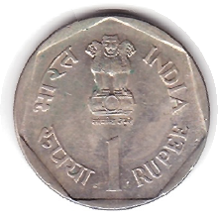 | 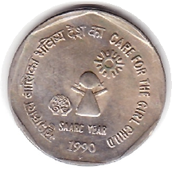
USA | Quarter Dollar | 1987 – Liberty – In God We Trust | 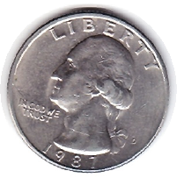 | 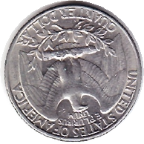
INDIA | 50 Paise | Indira Gandhi – 1917 - 1984 | 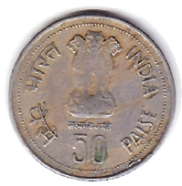 | 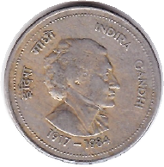
U.K. | 1 Pound | 1995 – Elizabeth II | 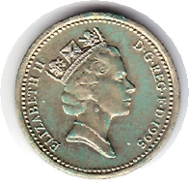 | 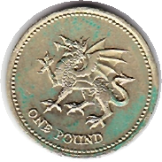
USA | 5 Cents | 1996 - Monticello | 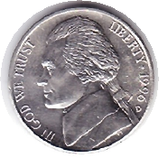 | 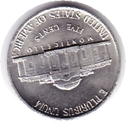
INDIA | 50 Paise | 1995 – Parliament House | 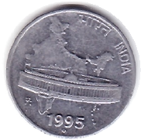 | 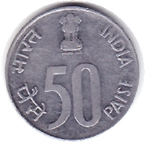
USA | 1 Dollar | LIBERTY - 1996 | 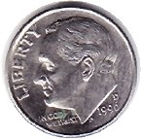 | 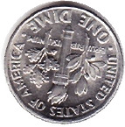
INDIA | 50 Paise | 1947 – 1997 : 50th Year of Independence | 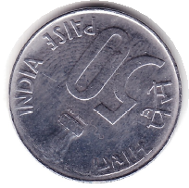 | 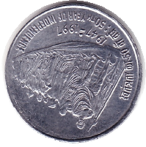
INDIA | 5 Naye Paise | 1963 | 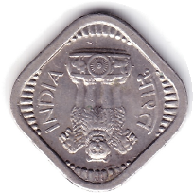 | 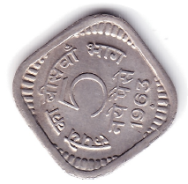
INDIA | 25 Paise | 1988 - Rhinoceros | 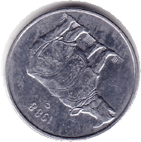 | 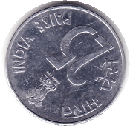
U.K. | 2 Pence | 1996 – Elizabeth II | 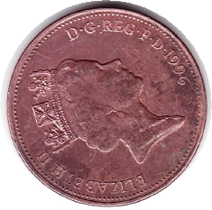 | 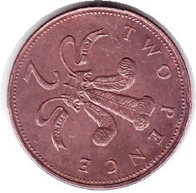
USA | 1 Dime | 1971 - Liberty | 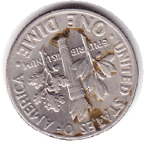 | 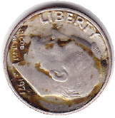
 |  |  | 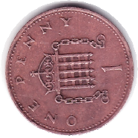 | 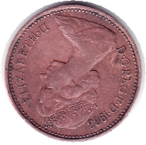
 |  |  | 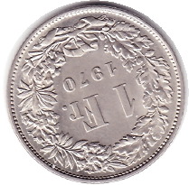 | 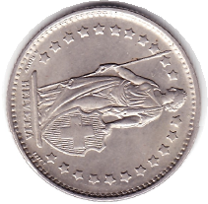
 |  |  | 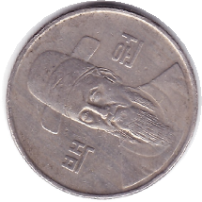 | 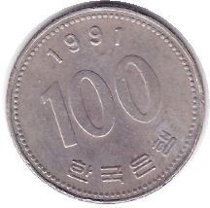
USA | 1 Dime | 1972 - Liberty | 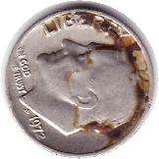 | 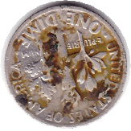
USA | 1 Dime | 1967 - Liberty | 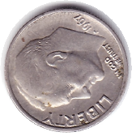 | 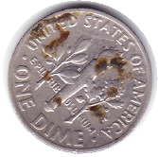
INDIA | 1 Rupee | 1990 - 15 Years of Integrated Child Development Services Scheme | 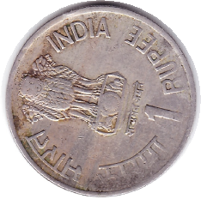 | 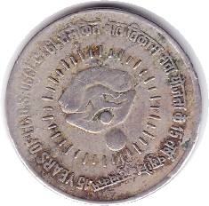
INDIA | 2 Rupees | 1998 – Deshbandhu Chittaranjan Das | 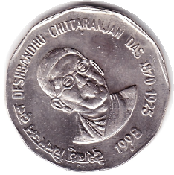 | 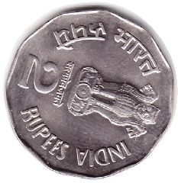
INDIA | 1 Rupee | 1989 – Jawaharlal Nehru Centenary | 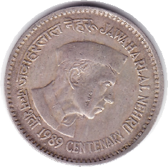 | 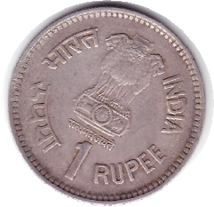
INDIA | 1 Rupee | 1999 : Sant Dnyaneshwar 1274-1296 | 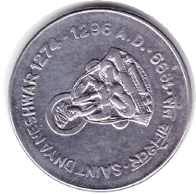 | 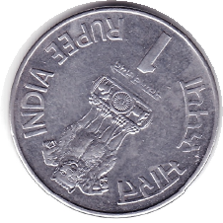
 |  |  | 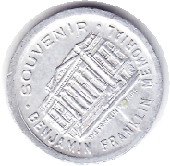 | 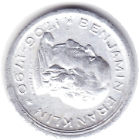
INDIA | 1 Rupee | 1987 – Small Farmers | 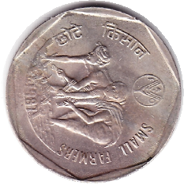 | 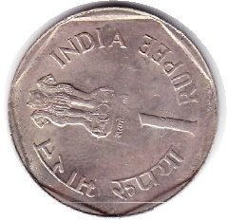
Japan | 100 Yens | 1993 | 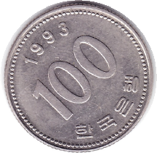 | 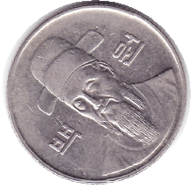
Japan | 1 Yen | 1996 | 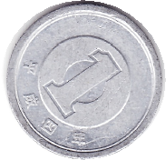 | 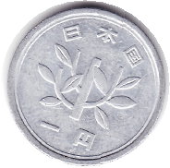
Japan | 10 Yen | 1965 | 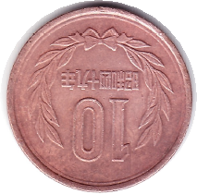 | 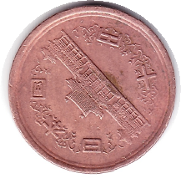
 |  |  | 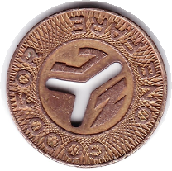 | 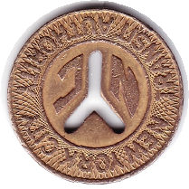
 |  |  | 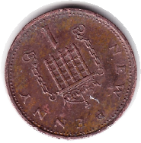 | 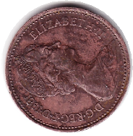
INDIA | 2 Rupees | 1997 : Subhas Chandra Bose Centenary | 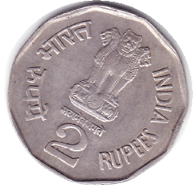 | 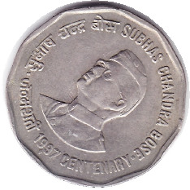
Netherlands | 25 Cents | 1972 | 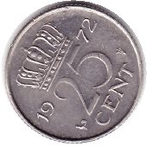 | 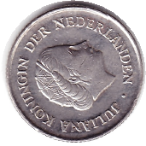
INDIA | 1 Rupee | Rajiv Gandhi 1944-1991 | 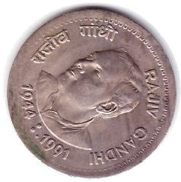 | 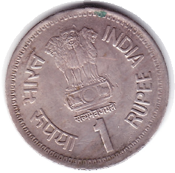
INDIA | 2 Paise | 1971 | 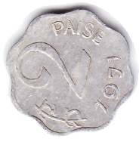 | 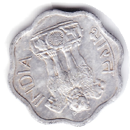
INDIA | 2 Rupees | Sardar Vallabh Bhai Patel | 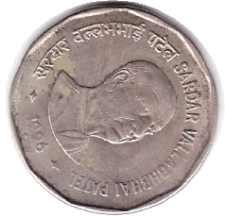 | 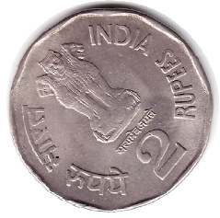
INDIA | 1 Rupee | 1990 : Dr. B.R. Ambedkar Centenary | 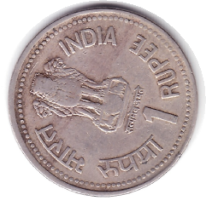 | 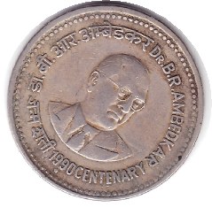
CANADA | 5 Cents | 1972 – Elizabeth II | 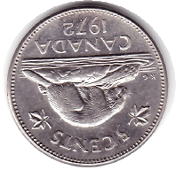 | 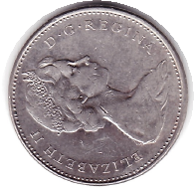
INDIA | 25 Paise | 1997 - Rhinoceros | 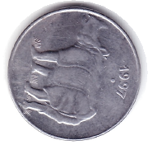 | 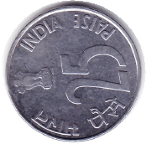
CANADA | 1 Cent | 1961 – Elizabeth II | 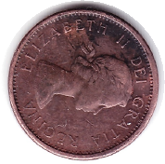 | 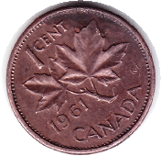
SOUTH KOREA | 10 V0n | 1994 | 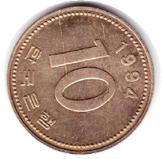 | 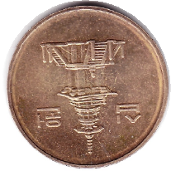
INDIA | 25 Paise | 1981 – World Food Day | 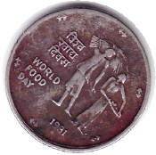 | 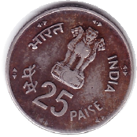
USA | 5 Cents | Monticello | 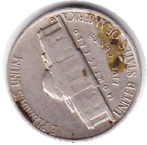 | 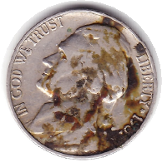
FRANCE | ½ Fr. | 1968 | 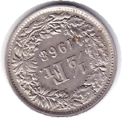 | 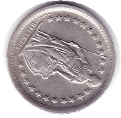
SWITZERLAND | 20  Rappen | 1971 – Confederatio Helvetica | 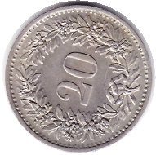 | 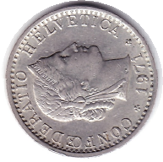
SWITZERLAND | 10 RAPPEN | 1971 – Confederatio Helvetica | 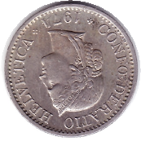 | 